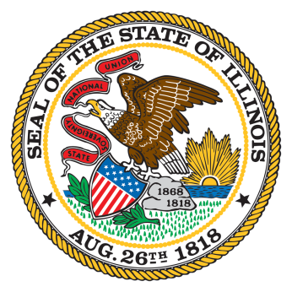

Illinois Workforce Innovation Board

JB Pritzker, Governor John Rico, Co-Chair
Erin Guthrie, Co-Chair

August 24, 2020
10:00am – 11:00am
(Please see meeting information below)

Executive Committee Meeting

- Approval of August 3, 2020 Meeting Minutes
COVID-19 Update | Julio Rodriguez
Education Stabilization Fund and Coursera Update | Lisa Jones
September IWIB Meeting Draft Agendas | Lisa Jones & Aimee Julian
  - Education Stabilization Fund Application Update
  - Coursera Update
  - Ratify IWIB Strategic Plan
  - Business Engagement Discussion
  - Introduction of the new IDES director
  - IDES presentation on unemployment numbers
  - IWP video for the awards
  - Update on the IWIB Unified Plan

- Old Business | Executive Committee Members
- New Business | Executive Committee Members
- Public Comment
- Adjournment
Next Executive Committee Meeting
  - Tuesday, September 8, 2020, 10:00 – 11:00am

IWIB Executive Committee Meeting
Mon, Aug 24, 2020 10:00 AM - 11:00 AM (CDT)
Please join my meeting from your computer, tablet or smartphone.
https://global.gotomeeting.com/join/362645797
You can also dial in using your phone.
United States: +1 (872) 240-3412
Access Code: 362-645-797
New to GoToMeeting? Get the app now and be ready when your first meeting starts: https://global.gotomeeting.com/install/362645797
10:00 – 11:00am
10:00 – 11:00am
10:00 – 11:00am
10:00 – 11:00am
10:00 – 11:00am
September 8, 2020 (Tuesday)
October 5, 2020
November 2, 2020
November 23, 2020
December 7, 2020

